DS TOOLS

Football Data Analysis Web Application

Team
العنابname:
الرجل

NAME | ID
اسلام اشرف نجم الدسوقي | 23011042
آسر حسام الدين سعد | 23011189
عبدالرحمن علي محمد اسماعيل | 23011102

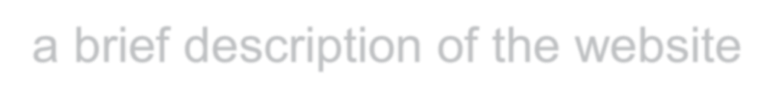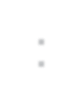
- a brief description of the website:
the website we will be scraping data from is
https://www.11v11.com ,it’s site offer match details, player and team statistics, football news

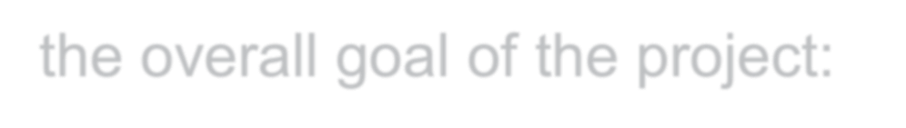
- the overall goal of the project:

analyze data for head-to-head matches
and show it for Premier League Teams
Data we will scrape for that: Away team (String),Home team (String),Score (int,), Competition(String), Match date & time(date)

Analyze Top 10 Team Performance in Premier League
Data we will scrape for that: Teams points(int), Team name(string), Game played(int),Team wins(int), Team draw(int),Team loses(int),Teams Goals For(int), Teams Goals For (int),Team Rank (int)


- Data Scraping: We will use BeautifulSoup and request for scrap data from website and if needed we will be handled with Selenium for dynamic scraping.


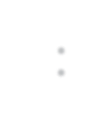
- Data Cleaning :We will handle missing values, remove inconsistent data entries, and apply regular expressions to clean and format textual data.

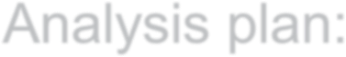
- Analysis plan: Analyze team head to head to show how is the best one, and Ranking teams based on performance

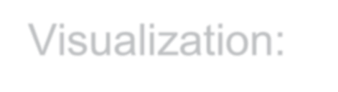
- Visualization:
1. Pie Chart: Draw and lose and win distribution
- Bar Chart : to show home and away advantages
- Bar Chart: To show top ten times point
- Bar Chart: to show Goals Scored vs Conceded

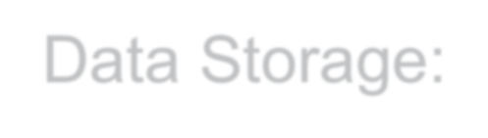
- Data Storage: To store the scraped and cleaned data for our project, we used MongoDB, a NoSQL document-based database.
Phase 2

- Introduction:-
We made this project as a streamlit-based web application that scrapes and analyses football data from (https://www.11v11.com). It provides two main functions:
- Head-to-Head Analysis: Compares historical match results between two teams.
- League Table Analysis: Displays league standings for a given date.

Packages used and their purpose:
- Selenium & BeautifulSoup for web scraping.
- MongoDB for data storage.
- Streamlit for the interactive UI.
- Matplotlib for data visualization.
- re for Regular expression
- pandas for Viewing data
---

- Code Explanation:-

- Web Scraping (`scrap.py`):-
This module gathers data from 11v11.com.

Key Functions:
1. head_to_head_data(team1, team2)
- Fetches historical matches between two teams.
- Uses Selenium (headless Chrome) to load dynamic content.
- Parses match data (date, teams, score, competition, winner).
- Returns a Pandas Data Frame and a list of dictionaries**.
-Regular expression :The function head_to_head_data(team1, team2) uses regular expressions to process match-related strings. Here's a breakdown:
- Split Team Names
re. split(r"\s+v\s+", teams_text)
  - Splits the teams_text string on the pattern " v " with optional spaces.
  - Example: "Liverpool v Arsenal" → ["Liverpool", "Arsenal"]
- Extract Score Digits
re.findall(r"\d+", score_text)
  - Finds all numbers in the score string (e.g., "2 - 1").
  - Returns: [2, 1]
- Match Date Format
re.search(r"(\d{1,2})\s+([A-Za-z]{3})\s+(\d{4})", date_text)
  - Captures dates like "12 Aug 2022" with three groups:
    - Day (\d{1,2}), Month abbreviation ([A-Za-z]{3}), and Year (\d{4}).
  - Enables conversion to a datetime object.
These expressions help reliably extract structured data from dynamic HTML content.

def head_to_head_data(team1,team2):
try:

## uses Selenium WebDriver with Chrome in headless mode to load a webpage and retrieve its HTML content.
chrome_options = Options()

chrome_options.add_argument("--headless")

chrome_options.add_argument("--disable-blink-
features=AutomationControlled") # Avoid bot detection

chrome_options.add_argument("user-agent=Mozilla/5.0 (Windows NT 10.0; Win64; x64) AppleWebKit/537.36 (KHTML, like Gecko) Chrome/91.0.4472.124 Safari/537.36")

chrome_driver_path = "./chromedriver.exe"

driver = webdriver.Chrome(service=Service(chrome_driver_path),
options=chrome_options)

driver.get(f"https://www.11v11.com/teams/{team1}/tab/opposingTeams/opposition/{team2}/")

print("page Loaded...")

html = driver.page_source

driver.quit()

soup = BeautifulSoup(html, "lxml")

matches = []

table = soup.find("table", class_="sortable")

for row in table.find_all("tr")[1:]:
cols = row.find_all("td")
date_text = cols[0].text.strip()
teams_text = cols[1].text.strip()
score_text = cols[3].text.strip()
competition = cols[4].text.strip()

HomeTeam, AwayTeam = re.split(r"\s+v\s+", teams_text)

home_goals, away_goals = map(int, re.findall(r"\d+", score_text))

date_match = re.search(r"(\d{1,2})\s+([A-Za-z]{3})\s+(\d{4})", date_text)
date = datetime.strptime(date_match.group(), "%d %b %Y") if date_match else "Unknown"

matches.append({
"Date": date,
"HomeTeam": HomeTeam.strip(),
"AwayTeam": AwayTeam.strip(),
"Score": f"{home_goals}-{away_goals}",
"Competition": competition,
"Winner": HomeTeam if home_goals > away_goals else AwayTeam if away_goals > home_goals else "Draw"
})

matches = pd.DataFrame(matches)

matches = matches[matches["Competition"].str.contains(r"premier league", flags=re.IGNORECASE)]

matches_list = matches.to_dict(orient="records")

return matches, matches_list

except Exception as e:
print(f"Error: {e}")

2. League_Standing(Date)
- Fetches league standings for a given date.
- Extracts team rank, wins, losses, goals, and points.
- Returns a Pandas data Frame.

def League_Standing(Date):
try:
# Configure Chrome options
chrome_options = Options()
chrome_options.add_argument("--headless")
chrome_options.add_argument("--disable-blink-features=AutomationControlled") # Avoid bot detection
chrome_options.add_argument("user-agent=Mozilla/5.0 (Windows NT 10.0; Win64; x64) AppleWebKit/537.36 (KHTML, like Gecko) Chrome/91.0.4472.124 Safari/537.36")

chrome_driver_path = "./chromedriver.exe"
driver = webdriver.Chrome(service=Service(chrome_driver_path), options=chrome_options)

# Fetch the page
url = f"https://www.11v11.com/league-tables/premier-league/{Date}/"
driver.get(url)
print("Page loaded...")

time.sleep(5)

html = driver.page_source
driver.quit()

soup = BeautifulSoup(html, "lxml")
table=soup.find("tbody").find_all("tr")[:10]
rank_list=[]
for team in table:
team_rank=team.find("td").text.strip()
team_name=team.find_all("td")[1].text.strip()
game_played=team.find_all("td")[2].text.strip()
team_win=team.find_all("td")[3].text.strip()
team_draw=team.find_all("td")[4].text.strip()
team_lose=team.find_all("td")[5].text.strip()
goals_for=team.find_all("td")[6].text.strip()
goals_in=team.find_all("td")[8].text.strip()
points=team.find_all("td")[9].text.strip()

rank_list.append({
"Team rank":int(team_rank),
"Team name":team_name,
"Game played":int(game_played),
"Team win":int(team_win),
"Team draw":int(team_draw),
"Team lose":int(team_lose),
"Goals for":int(goals_for),
"Goals in":int(goals_in),
"Points":int(points)
})

Ranks=pd.DataFrame(rank_list)
ranks_dic = Ranks.to_dict(orient='records')

return Ranks,ranks_dic
except Exception as e:
print("Please enter the date in this format: dd-month-yyyy (e.g., 07-April-2024). The year must be between 1993 and 2025, and the month should be written in English.")
return None

---------------------------------------------------------------------------------------------------------------------------

- MongoDB Storage (`mongo.py`):-
Stores scraped data in a local MongoDB database (`football_db`).

Key Functions:
- First connect to mongo and create football_db and
Head_to_head and League standing Collection:

#connect to mongo db
try:
# Connect to MongoDB with timeout and server selection timeout
print("Attempting to connect to MongoDB...")
client = MongoClient('mongodb://localhost:27017/',
serverSelectionTimeoutMS=5000, # 5 second timeout
connectTimeoutMS=5000)

# Verify the connection
client.server_info() # This will raise an exception if connection fails
print("Successfully connected to MongoDB!")

# Get database and collections
db = client['football_db']
head_to_head_collection = db['head_to_head_matches']
league_table_collection = db['league_tables']

# Verify database exists
if 'football_db' not in client.list_database_names():
print("Creating database 'football_db'...")

# Verify collections exist
if 'head_to_head_matches' not in db.list_collection_names():
print("Creating collection 'head_to_head_matches'...")
if 'league_tables' not in db.list_collection_names():
print("Creating collection 'league_tables'...")

except Exception as e:
print(f"Error connecting to MongoDB: {e}")
print("Please make sure MongoDB is installed and running on your system.")
sys.exit(1)

- store_head_to_head_matches(team1, team2, matches)
- Inserts head-to-head match data into `head_to_head_matches` collection.

def store_head_to_head_matches(team1, team2, matches):
try:
# Create document with match data
match_data = {
"team1": team1,
"team2": team2,
"matches": matches,
"stored_at": datetime.now()
}
exist=head_to_head_collection.find_one({"team1": match_data["team1"],"team2": match_data["team2"]})
if not exist:
print("Storing head-to-head matches...")
result = head_to_head_collection.insert_one(match_data)
print(f"Head-to-head matches successfully stored with ID: {result.inserted_id}")
return result.inserted_id
else:
print("Data for this date already exists.")

except Exception as e:
print(f"Error storing head-to-head matches: {e}")
return None

- store_league_table(date, rank_list)
- Inserts league standings into `league_tables` collection.

def store_league_table(date, rank_list):
try:
# Create document with league table data
table_data = {
"date": date,
"teams": rank_list,
"stored_at": datetime.now()
}
exist=league_table_collection.find_one({"date": table_data["date"]})

if not exist:
print("Storing league table data...")
result = league_table_collection.insert_one(table_data)
print(f"League table data successfully stored with ID: {result.inserted_id}")
return result.inserted_id
else:
print("Data for this date already exists.")
except Exception as e:
print(f"Error storing league table data: {e}")
return None

---------------------------------------------------------------------------------------------------------------------------

- Streamlit UI (`app.py`):-
Provides an interactive dashboard with two pages.

Key Features:
- Head-to-Head Analysis Page
- Users select two teams.
- Displays match history, win/loss stats, and visualizations.

if page == "Head-to-Head Analysis":
team1_select = st.selectbox("Enter Team 1", list(teams1_display_to_value.keys()))
team2_select = st.selectbox("Enter Team 2", list(teams2_display_to_value.keys()))
if st.button("Analyze Head-to-Head"):
matches, matches_list = fetch_head_to_head(team1, team2)
st.dataframe(matches)

- League Table Analysis Page
- Users select a date.
- Displays league standings, top teams, and goal statistics.

if page == "League Table Analysis":
date = st.date_input("Select Date", datetime.now())
if st.button("Get League Table"):
rank_list = fetch_League_Table(formatted_date)
st.dataframe(rank_list)
# ... (visualizations)

- Visualization:
1.Bar Chart of Team Points (Example):

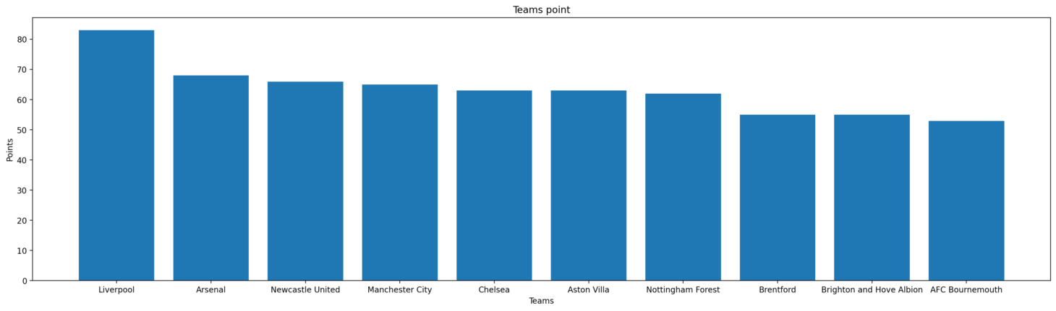
2.GOAL in vs Goal for (Example) :
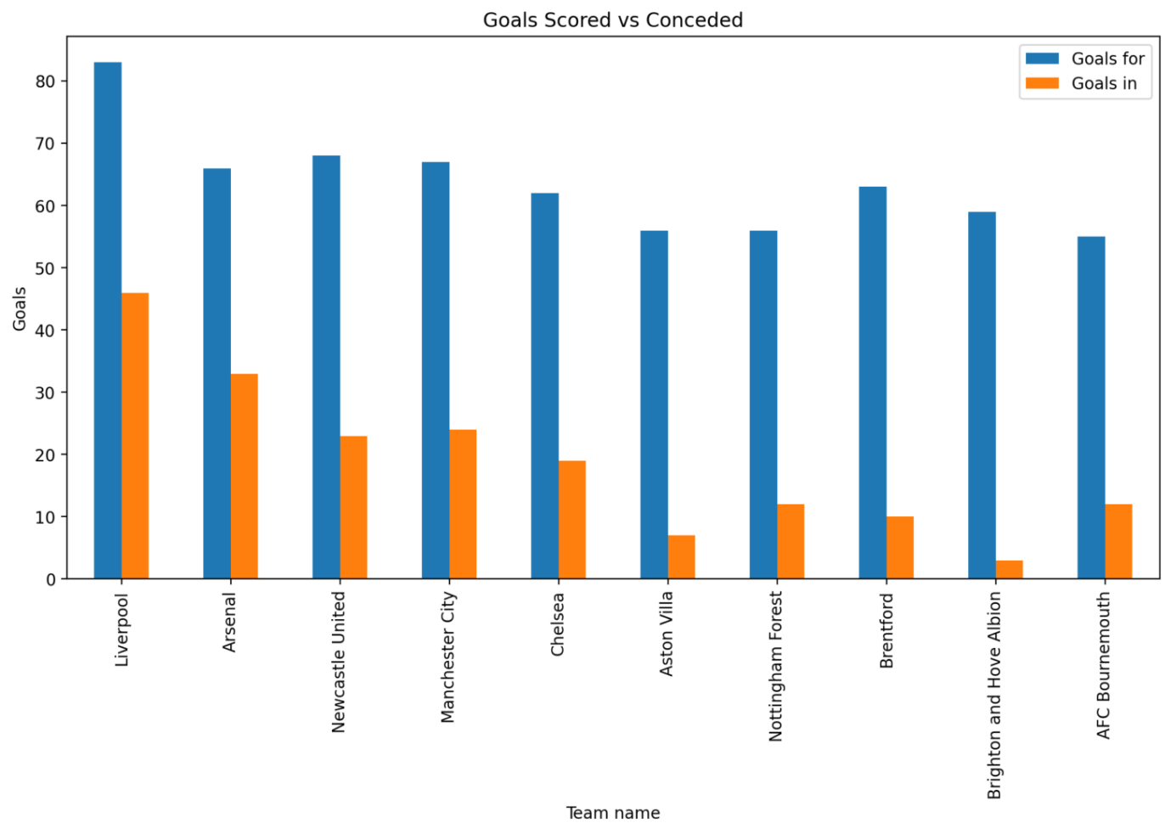

Win/Loss/Draw Pie Chart (Example):
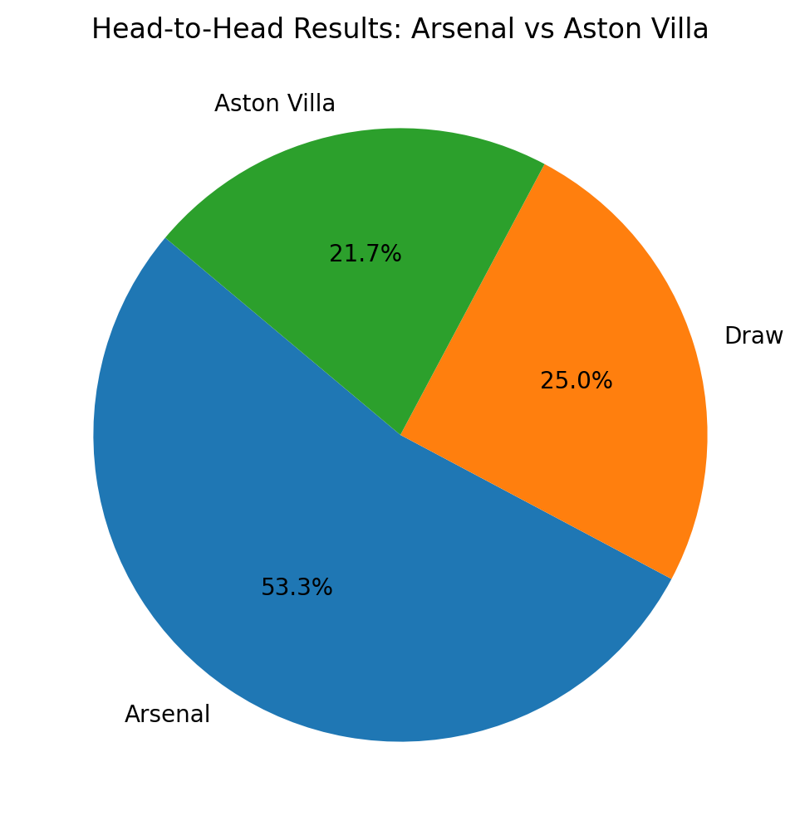
Home vs Away Advantage (Example):
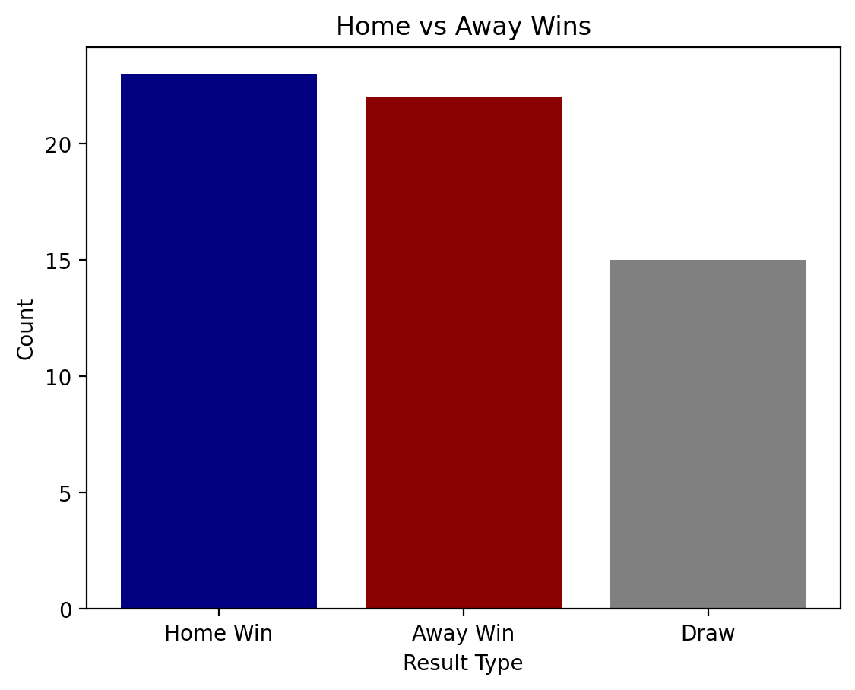
-------------------------------------------------------------------------------------------------------------------
3.Bouns Task:-
- We Deploy Our results using Streamlit to create an interactive web app for presenting the analysis.

- Upload data on github repo to deploy it with streamlit:
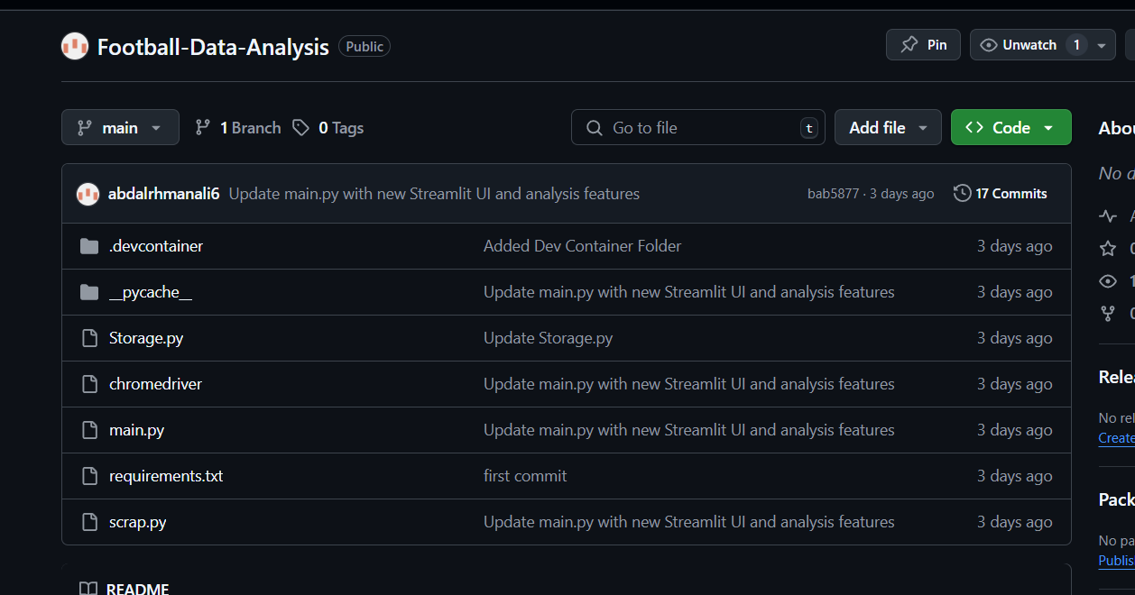

- Then deploy the app using Streamlit to be used by other users:
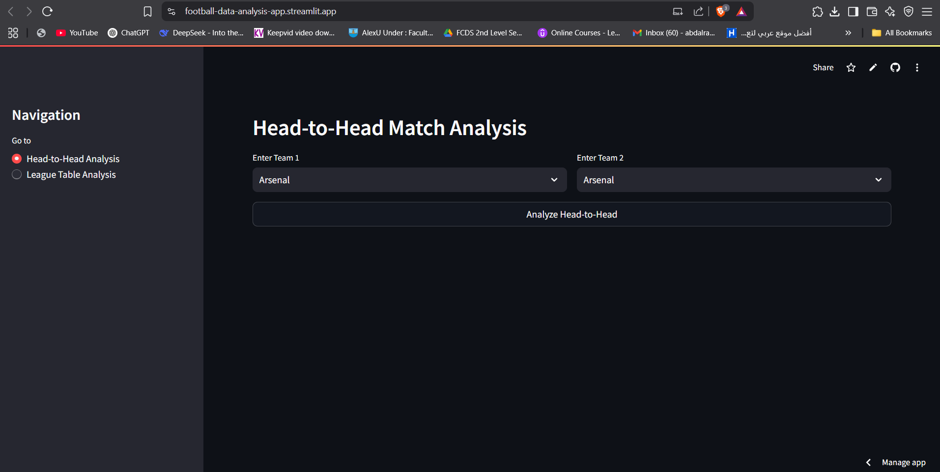

4. Results & Outputs:-

- Head-to-Head Analysis:
Example Input:
- Team 1: ‘Arsenal’
- Team 2: ‘Chelsea’

Output:
- A table of past matches.
- Win/loss/draw statistics.
- Pie chart of results.
- Bar chart of home vs. away performance.

![Head-to-Head Analysis Example](https://via.placeholder.com/600x400?text=Head-to-Head+Analysis) *(Example visualization placeholder)*

---

- League Table Analysis:
Example Input:
- Date: ‘07-April-2024’

Output:
- League standings table.
- Top team, most goals, most points.
- Bar chart of team points.
- Goals scored vs. conceded comparison.

![League Table Analysis Example](https://via.placeholder.com/600x400?text=League+Table+Analysis) *(Example visualization placeholder)*

-----------------------------------------------------------------------------------------------------

5. Conclusion:-
This project successfully:
. Scrapes football data from 11v11.com.
. Stores data in MongoDB for future use.
. Provides an interactive UI with Streamlit.
. Visualizes key statistics with Matplotlib.

This application is useful for football analysts, teams, and fans who want historical insights into team performance.

Thank You

